**Sequence Diagram 1: When user starts Application**

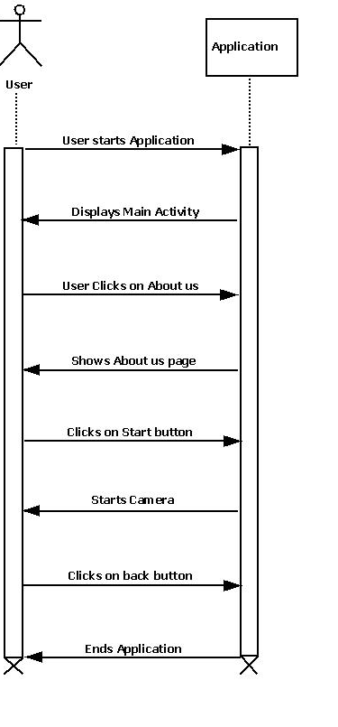

**Sequence Diagram 2: When User Clicks on About us page**

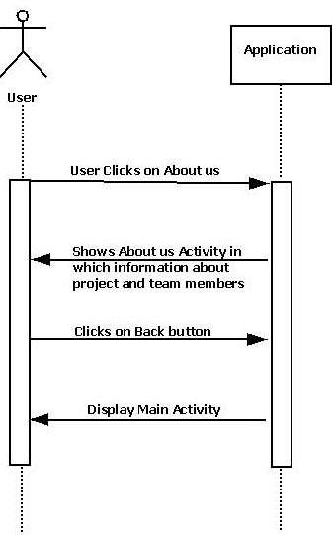

**Sequence Diagram 3: When user clicks on start**

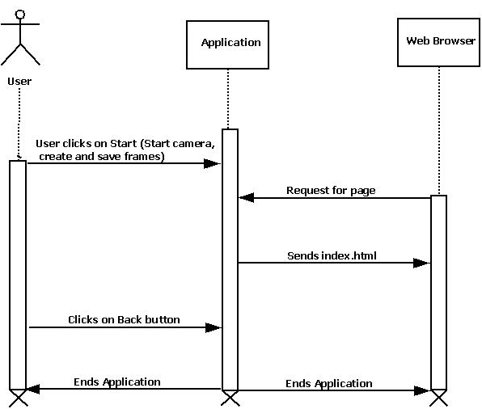

**Deployment Diagram:**

